Create database ,table.

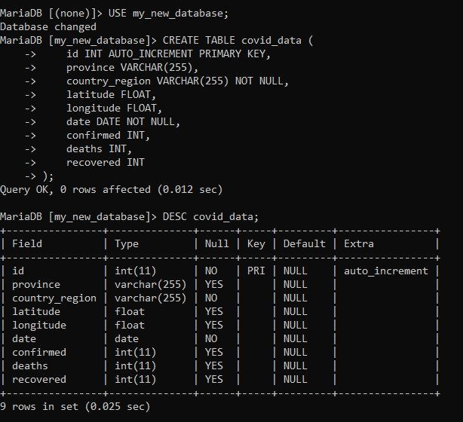

Load dataset.

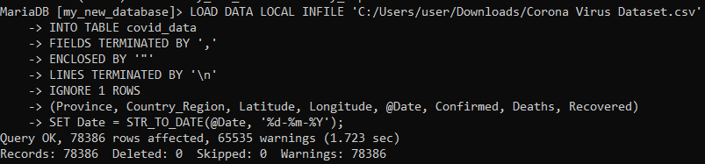

-- Q1. Write a code to check NULL values

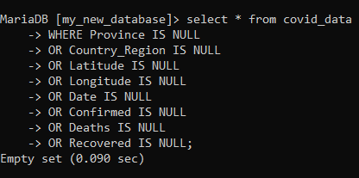

--Q2. If NULL values are present, update them with zeros for all columns.

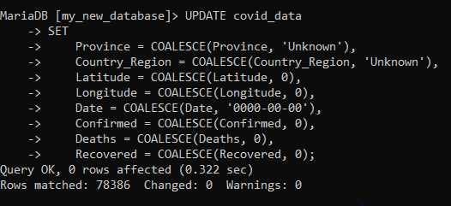

-- Q3. check total number of rows

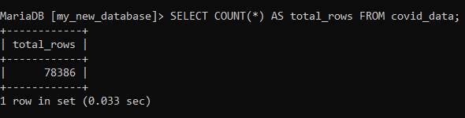

-- Q4. Check what is start_date and end_date

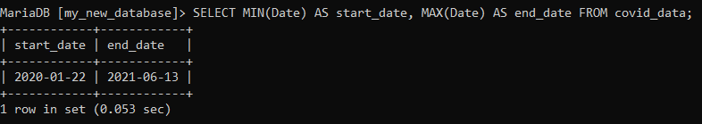

-- Q5. Number of month present in dataset

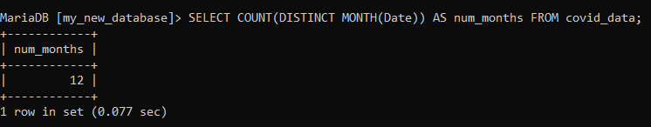

-- Q6. Find monthly average for confirmed, deaths, recovered

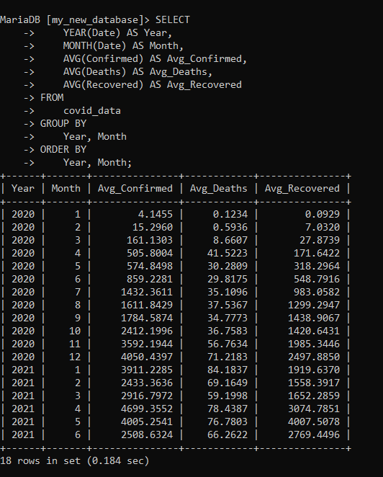

-- Q7. Find most frequent value for confirmed, deaths, recovered each month

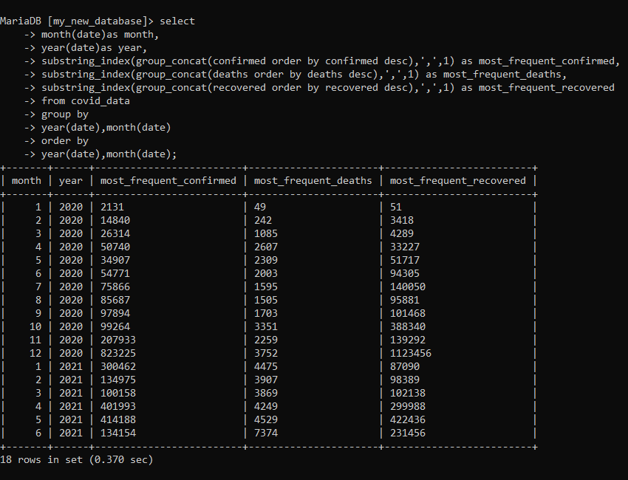

-- Q8. Find minimum values for confirmed, deaths, recovered per year

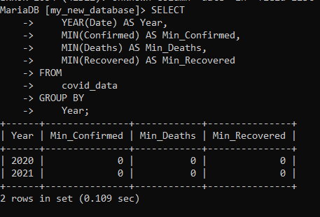

-- Q9. Find maximum values of confirmed, deaths, recovered per year

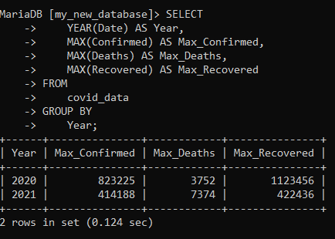

-- Q10. The total number of case of confirmed, deaths, recovered each month

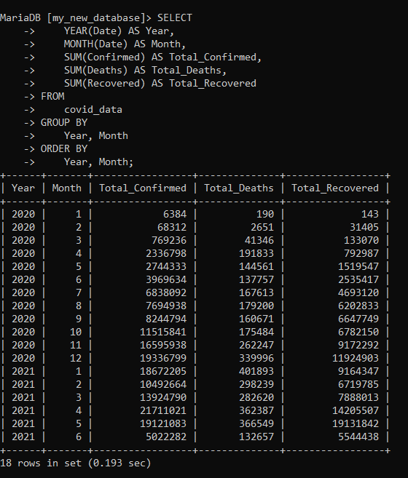

-- Q11. Check how corona virus spread out with respect to confirmed case (Eg.: total confirmed cases, their average, variance & STDEV )

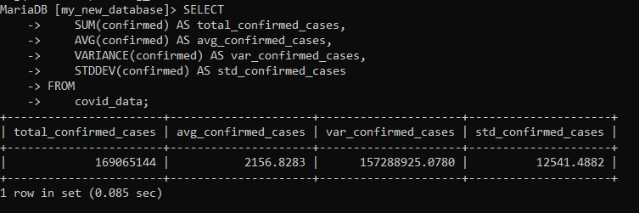

-- Q12. Check how corona virus spread out with respect to death case per month(Eg.: total confirmed cases, their average, variance & STDEV )

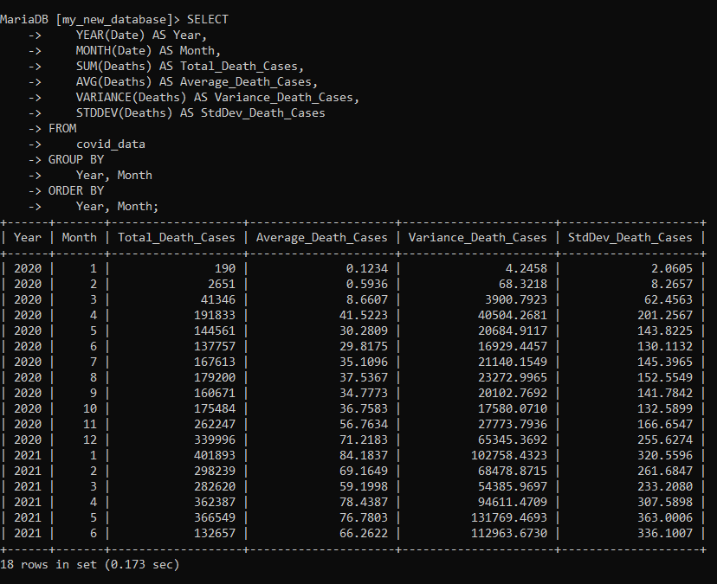

-- Q13. Check how corona virus spread out with respect to recovered case(Eg.: total confirmed cases, their average, variance & STDEV )

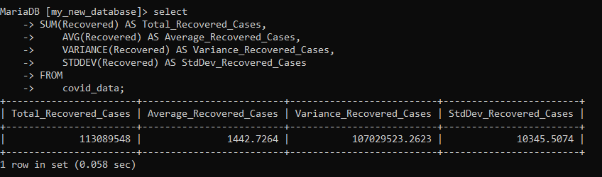

-- Q14. Find Country having highest number of the Confirmed case

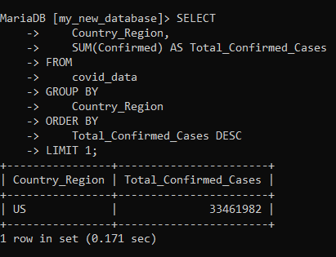

-- Q15. Find Country having lowest number of the death case

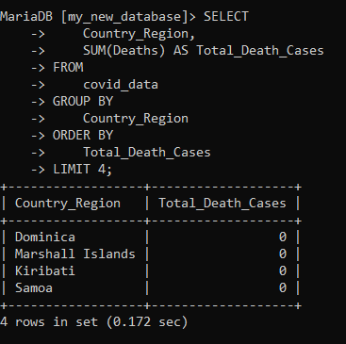

-- Q16. Find top 5 countries having highest recovered case

